An evaluation of the benefits of artificial habitats for red snapper, Lutjanus campechanus, in the northeast Gulf of Mexico

SZEDLMAYER, S.T.
Marine Fish Laboratory
Department of Fisheries and Allied Aquaculture
Auburn University
8300 State Hwy 104
Fairhope, AL 36532

ABSTRACT
Evidence for red snapper, Lutjanus campechanus, production from artificial habitats has been difficult to obtain. The benefits of such habitats for red snapper were evaluated by examining red snapper diets, predator exclusions, habitat complexity, and epibenthic communities in association with artificial habitats over a 10 year period. Also examined were movement patterns from ultrasonic telemetry, and population parameters estimated from fishery independent methods. These studies suggested that red snapper: 1) had a high affinity for artificial habitats, 2) showed consistent feeding on reef prey types, 3) were significantly more abundant on habitats with available prey, 4) showed a significant correlation between abundance and habitat complexity, 5) showed long term residency with some tracked over two years, and 6) abundance significantly increased when predators were excluded. In addition, population status of red snapper off coastal Alabama based on a fishery independent survey of 94 artificial habitats, using fish traps, diver surveys, and otolith aging suggested a better condition compared to previous population assessments. Collectively these results suggest that artificial habitats in the northern Gulf of Mexico contribute significantly to the production of red snapper.

KEYWORDS: red snapper, otolith aging, predator exclusion, diet, artificial reef

Una evaluación de los beneficios de los hábitat artificiales del huachinango del Golfo, Lutjanus campechanus, en el noreste del Golfo de México

La evidencia del huachinango del Golfo, Lutjanus campechanus, en cuanto a su producción en hábitat artificiales ha sido difícil de obtener. Los beneficios de dichos hábitat para el huachinango del Golfo fueron evaluados examinando sus dietas, la exclusión de depredadores, la complejidad del hábitat, y las comunidades epibénticas asociadas con los hábitats artificiales por un periodo de 10 años. También fueron examinados los patrones de movimiento de la telemetría ultrasónica, y los parámetros de la población, estimados, usando métodos independientes de los de pesca. Estos estudios indicaron que el huachinango del Golfo: 1) tiene una alta afinidad con los hábitat artificiales, 2) mostró alimentación consistente con tipos de presas del arrecife, 3) fueron significantemente más abundantes en hábitat con mayor número de presas disponibles, 4) mostró números significantemente más altos en hábitat con una elevada complejidad, 5) mostró residencia a largo plazo (algunos rastreados por más de dos años), y 6) mostró significantes efectos de exclusión de depredadores. Además, el estatus de la población del huachinango del golfo fuera de la costa de Alabama, basado en un sondeo de pesca independiente de 94 hábitat artificiales, usando trampas de pescar, encuestas de buceo , y otolite de edad sugirieron una mejor condición, en comparación a cálculos o evaluaciones previas. Colectivamente, estos resultados indicaron que los hábitat artificiales en el golfo norte de México contribuyen significativamente a la producción del huachinango del golfo.

PALABRAS CLAVE: huachinango del Golfo, otolite de edad, exclusión de depredadores, dieta, arrecife artificial

INTRODUCTION
In the aquatic environment almost any material that adds some topographical relief will attract fish and increase catch (D'Itri 1985). In coastal Alabama, U.S.A., this concept has been applied extensively with the placement of artificial habitats (Minton and Heath 1998). However, we know little about the actual effects of artificial habitats on wider scales, such as local fish stocks. If artificial habitats function mainly through attraction then we may be driving fish stocks towards faster depletion. In contrast, if artificial habitats function by increasing productivity then our habitat building efforts would be helping dwindling fish stocks. Despite the vast amount of literature on artificial habitats this critical question has not yet been adequately answered (Bohnsack 1989, Grossman et al. 1997, Bortone 1998). To address such questions, over a 10 year period we have examined many aspects of the life history and ecology of red snapper, Lutjanus campechanus, in the northeast Gulf of Mexico, and how this species relates to artificial habitats.
Red snapper have historically supported an important commercial and recreational fishery (Camber 1955) and are closely associated with structured artificial habitats (Szedlmayer 1997, Szedlmayer and Lee 2004, Szedlmayer and Schroepfer 2005, Lingo and Szedlmayer 2006, Schroepfer and Szedlmayer 2006, Piko and Szedlmayer 2007). In the northeast Gulf of Mexico most natural habitat is relatively flat open mud/sand/shell substrata with uncommon or rare complex natural rock reef habitats with associated reef biota (Parker et al. 1983, Schroeder et al. 1988, Mitchell et al. 1992, 1993). Over the last 50 years part of this shelf habitat has been altered with extensive building of artificial habitats. In the northern Gulf of Mexico, more than 14,000 artificial habitats have been built including thousands of oil and gas platforms (Minton and Heath 1998). These artificial habitats show large accumulations of reef fish species, especially red snapper (Lingo and Szedlmayer 2006; Szedlmayer et al. 2004). Again, the important question concerning this area of the northeast Gulf, is whether or not the reef building activities are enhancing shelf habitat through increased fish production or causing detrimental effects, i.e., overfishing due to ease of locating concentrated fish stocks (Grossman et al. 1997).

Life History and Habitats
Juvenile red snapper first settled from the plankton at around 17 mm TL and 26 d after hatch, and showed significant preference for shell habitats in field trawl surveys (Szedlmayer and Conti 1999, Rooker et al. 2004) and laboratory studies (Szedlmayer and Howe 1997). Relic-shell habitat was identified as a primary nursery location of juvenile red snapper, with mean CPUE at 4000 fish h⁻¹ trawl time, which far exceeded CPUE from nearby habitats that lacked relic-shell and all previous estimates (Szedlmayer and Conti 1999). Also, SCUBA observations of several low relief (approx. 20 cm) artificial substrates including oyster shells, showed significant attraction of juvenile red snapper to all sites (Workman and Foster 1994, Lingo and Szedlmayer 2006, Piko and Szedlmayer 2007). In visual observations from the above studies we observed many newly settled recruits at just under 30 mm TL, all of which were associated with some type of structure, similar to observations by Workman and Foster (1994).
After their initial settlement in July and August, age-0 red snapper will quickly outgrow their initial habitat and seek larger more structured habitats (Szedlmayer and Conti 1999, Rooker et al. 2004 Szedlmayer and Lee 2004). These observation of age-0 red snapper showing increased numbers on 1 m³ concrete habitats in the fall suggested a recruitment to higher relief structure at earlier ages compared to previous reports that suggested recruitment to “higher” structure only after reaching age-1 or older (Render 1995, Gallaway et al. 1999).
One of the most obvious reasons for moving to more structured habitats would be to reduce predation pressure. For example, when age-0 first settle at around 20 mm TL, smaller structure such as oyster shells would provide adequate shelter, but as size increases in the fall, fish need increased “hole” size (Hixon and Beets 1989). In studies with predator exclusion cages, there was a clear predator exclusion effect, where shell habitats with predator exclusion cages had significantly more age-0 red snapper. Artificial habitat complexity was also associated with higher abundance of red snapper and several other species (Lingo and Szedlmayer 2006, Piko and Szedlmayer 2007).
From these life history studies it is clear that red snapper are closely associated with artificial habitats. They recruit to such structures at an early age, and probably benefit from increased complexity and potential predator protection.

Red Snapper Diets
One of the most important questions concerning red snapper and the function of artificial habitats must address feeding responses to changing habitats. When red snapper first settle they forage on prey types from open sand-mud habitats. When fish shifted to more structured habitats they show a corresponding shift to more feeding on reef prey types (Szedlmayer and Lee 2004). As red snapper grow they continue this shift to significant feeding on reef prey types but will also continue feeding on almost any available prey. One aspect that may confuse the question of red snapper feeding types is that red snapper show significant diel shifts with feeding on different prey types depending on day or nighttime capture (Ouzts and Szedlmayer 2003). Another aspect that makes feeding studies difficult is that red snapper stomachs frequently are empty due to barotropic stress, or large numbers fish prey are unidentifiable due to advanced digestion. However, SCUBA observation of large schools (> 500) of mixed species of tomtate Haemulon aurolineatum, vermilion snapper Rhomboplites aurorubens, and round scad Decapterus punctatus at small sizes (around 60 mm TL) on many artificial habitats, suggests that reef prey fish were available (Szedlmayer unpublished data). Future diet studies that are able to positively identify prey species (e.g., DNA) may confirm increased feeding on these reef prey types. As red snapper continue to grow older and larger there exist little quantitative information on diets. At present we know of no studies that have quantitatively examined the diets of larger older red snapper, for example fish > 900 mm TL.
In another study concerning artificial habitats and red snapper potential prey items, the recruitment of juvenile red snapper was compared between artificial habitats with and without epibenthic prey communities (Redman and Szedlmayer In review). Copper-based antifouling paint was used to prevent the development of epibenthic organisms and red snapper abundance was compared between habitats with (n = 20) and without (n = 20) these communities over a 12 month period. Red snapper preferred habitats with epibenthic communities, and were significantly larger on these habitats. This study showed that potential food resources affected the recruitment of juvenile red snapper to artificial habitats in the northern Gulf of Mexico. Thus, the attraction of fishes to artificial habitats was not just in response to shelter, but also the associated epibenthic communities.
Conclusions from diet studies showed that red snapper utilized “reef” prey types that would not have been available without the construction of artificial habitats, and also showed significantly higher red snapper abundances on artificial habitats that had epibenthic communities compared to identical habitats that lacked these communities.

Red Snapper Movements
Early studies of red snapper movement with conventional t-bar or anchor tags suggested long-term residence around hard bottom structures (Camber 1955, Moseley 1966, Bradley and Bryan 1975). Similarly, mark-recapture studies of red snapper have shown little movement and high site fidelity around artificial habitats. Beaumariage (1969) tagged 1,372 red snapper and 97% of recaptured tagged fish stayed at the original tagging site. Szedlmayer and Shipp (1994) tagged 1,155 red snapper and 76% of recaptured tagged fish stayed within 2 km. Watterson et al. (1998) tagged 1,604 red snapper and 61% of recaptured tagged fish stayed at the tagging site.
Some studies have also suggested greater movements of 5-275 km for tagged red snapper which would reduce the importance of artificial reefs. For example, Watterson et al. (1998) reported movements up to 265 km, and attributed this movement with the occurrence of hurricane Opal. Patterson et al. (2001) tagged 2,932 red snapper and observed that mean distance moved was 29 km and maximum distance moved was 352 km. However, mark-recapture studies with conventional tags assume the reliability of reporting date of capture, and most importantly the reliability of reporting site of capture from external sources (Schwartz 2000; Denson et al. 2002). Ultrasonic telemetry removed these assumptions and showed that red snapper were resident on artificial habitats in the northeastern Gulf of Mexico for 17-597 d (Szedlmayer 1997; Szedlmayer and Schroepfer 2005; Schroepfer and Szedlmayer 2006).
Red snapper may in fact show several different movement patterns depending on life stage. Clearly age-0 red snapper settle to benthic habitats early (26 d) but then move to more structured habitats in the fall of their first year (Szedlmayer and Conti 1999; Szedlmayer and Lee 2004). As fish grow during the first and second years they may still be in the process of seeking a suitable habitat. This type of behavior might result in shorter residence time estimates and longer distances between mark recaptures (Watterson et al. 1998; Patterson et al. 2001). Then as fish become larger and older (>2 years), they are better able to establish longer residence on more suitable artificial habitats (Schroepfer and Szedlmayer 2006). More suitable habitat is defined here as providing adequate protection as well as food resources, i.e., not all artificial habitats are alike. Then, as fish reach very large sizes (e.g., > 900 mm TL) they are no longer limited by predation pressure and may be able to move over wide ranging habitats with relative impunity to predation. Some evidence for such habitat shifts for older larger red snapper is supported by open habitat longline catches of high numbers of very large older red snapper (Henwood et al. 2004, Mitchell et al. 2004). Little other direct information from tagging studies has been obtained for larger older red snapper.
In conclusion, young to intermediate age red snapper (approximately 3 to 10 year old fish) show high affinity for artificial habitats with long term residence. What movement patterns will be shown for larger older fish (for example > 15 years) is still speculative.

Growth and Population Assessment
Accurate stock assessment is critical to the management of marine reef fish populations in the northeast Gulf of Mexico. This assessment task often proves difficult because of the inherent difficulty of sampling reef fishes with complicated life history patterns, and cryptic habitats. These sampling problems have little to do with assessment effort, i.e., since the early 90's there have been extensive stock assessments for this species. Previous stock assessments have suggested an overfished red snapper stock, and without a reduction in the annual total allowable catch, the red snapper stock will not reach the required target level (F/Fmsy and B/Bmsy) by the year 2032 (DEIS 2006).
One difficulty was that almost all previous stock assessments were based on fishery dependent landing data rather than fishery independent surveys (Goodyear 1995, Schirripa and Legault 1999, Cass-Calay and Ortiz 2004, Porch 2004). This problem has been well recognized in the fisheries literature. “Catch per unit effort can vary over time in commercial and recreational fisheries, is subject to fishers’ optimizing behaviors, and is not usually the most appropriate index” (Committee on Fish Stock Assessment Methods, Natural Research Council, 1998). Also, they state “fishery independent surveys offer the best opportunity for controlling sampling conditions by maintaining consistent gear, spatial coverage, timing and survey design”. In a fishery independent long-line survey many larger older-aged red snapper were collected (Henwood et al. 2004, Mitchell et al. 2004). These collections were difficult to integrate into present stock assessments, yet they may indicate that red snapper stocks may be in better condition than suggested by past assessments. In the present study, several data sets were used to estimate red snapper abundance, age frequency, mortality and population status off coastal Alabama. SCUBA surveys of age-0 and age-1 red snapper abundance on artificial shell/block nursery habitats were used to estimate juvenile mortality rates (320 shell/block nursery habitats from 1998 through 2002; Lingo and Szedlmayer 2006; Piko and Szedlmayer 2007). Mark-recapture studies were used to estimate fishing mortality (Szedlmayer and Shipp 1994), and fishery independent collections with fish traps, hook-and-line, and SCUBA visual surveys were used to estimate red snapper population parameters from artificial habitats (Szedlmayer et al. 2004).
Based on a total of 649 SCUBA surveys on these shell/block habitats, mean annual total mortality Z = 2.3, for age-0 to age-1 red snapper, similar to previous estimates of Z = 1.98 (Nichols et al. 2005) and Z = 2.12 (Nance 1998, Fig. 1). Previous estimates of trawl fishing mortality for age-0 to age-1 were relatively high, up to F = 1.38 (Nichols et al. 2005). With reduced trawling due to a fishing fleet reduction lower values may be applied for age-0 fish (F = 0.4 used in the present model, lower than F = 0.18 used in past stock assessments, C. Porch, NMFS, pers. comm.).
We used the same mortality rates for age-1 to age-2 used in past stock assessments (C. Porch NMFS, pers. comm). Fishing mortality rates for age 2 to 54 were based on past mark recapture studies. From May 1990 to Oct 1991, Szedlmayer and Shipp (1994) tagged and released 1,155 red snapper and recaptured 146 red snapper, and after accounting for tag shedding and fisher non-reporting annual F + SD = 0.19 + 0.16. From 1999 to 2004, ages were estimated from otoliths for 3,413 fish from 94 different artificial habitats, and from these ages total annual mortality was estimated at Z = 0.54 for red snapper greater than age-1 (Fig. 2). Growth was fitted to the von Bertalanffy relation where TL = 923 (1 - e ^{-0.17(age+0.79)} ) and Log wt = -0.471 + 2.96 log TL (R² = 0.98, N = 3,451, Szedlmayer et al. 2004). The most difficult parameter to estimate is natural mortality and values have widely ranged from 0.01 to 0.4 (Nelson and Manooch 1982; Schirripa and Legault 1999). In the present study, natural mortality was based on the difference between total mortality and fishing mortality, with the present estimated M = 1.9 for age-0, M = 0.60 for age 1, and M = 0.35 for > age-2 (Table 1). Combining ages, growth rates, mortalities and length-weight relations, the estimated transitional spawning potential ratio = 0.21 at F = 0.19, and maximum yield was attained when F was increased to 0.3 (Slipke and Maceina 2005; Figs. 3 and 4).
These model results suggested that red snapper populations off coastal Alabama may be in better condition compared to past assessments. Based on these fishery independent data red snapper stocks off coastal Alabama may be at stock levels needed for a sustainable fishery. For example, although considered overfished since the early 90's there has been little indications of decline in landings independent of catch level restrictions. One difficulty in this assessment was that data only originated from coastal Alabama and Mississippi. Clearly there may be significant differences in comparison to other areas such as Louisiana or Texas. One aspect that may account for assessment differences was that off coastal Alabama the artificial habitat program was by far the largest in the nation with some 15,000 artificial habitats in designated habitat building zones. Such correlations between artificial habitats and population estimates are difficult to prove, but combined with other more direct ecological measures, adds further to the evidence that artificial habitats have positively affected red snapper stocks off coastal Alabama.

Conclusions
Artificial habitats off coastal Alabama have enhanced red snapper stocks, based on the collective studies over more than 10 years showing 1) early recruitment to structured habitats, 2) high residence and affinity for structured habitats, 3) diet composition showing significant reef prey in combination with other prey types, 4) growth rates showing similar plots as previous estimates, and 5) a fishery independent survey of artificial habitats that suggested a better local stock condition compared to past estimates.

Acknowledgments
I thank, A. Chapin, J. Conti, C. Furman, C. Gurshin, J. Lee, M. Lingo, C. MacKichan, D. Moss, A. Ouzts, A. Piko, R. Redman, J. Simms, M. Topolski, and R. Wingate for help in the field and laboratory analyses. This project was funded by the Gulf and South Atlantic Fisheries Foundation, Marine Resources Division Alabama Department of Conservation, National Marine Fisheries Service MARFIN program, and is a contribution of the Alabama Agricultural Experiment Station, Department of Fisheries and Allied Aquacultures, Auburn University.

LITERATURE CITED

Beaumariage, D.S. 1969. Returns from the 1965 Schlitz tagging program including a cumulative analysis of previous results. Florida Department of Natural Resources Technical Series, St. Petersburg, Florida USA. 59:1-38.

Bohnsack, J.A. 1989. Are high densities of fishes at artificial reefs the result of habitat limitation or behavior preference? Bulletin of Marine Science 44:631-645.

Bortone, S.A. 1998. Resolving the attraction-production dilemma in artificial reef research: some yeas and nays. Fisheries 23:6-10.

Bradley, E. and C.E. Bryan. 1975. Life history and fishery of the red snapper (Lutjanus campechanus) in the Northwestern Gulf of Mexico. Proceedings of the 27th annual Gulf and Caribbean Fisheries Institute and the 17th annual International Game Fish Research Conference 27:77-106.

Camber, C.I. 1955. A survey of the red snapper fishery of the Gulf of Mexico, with special reference to the Campeche Banks. State of Florida Board of Conservation Technical Series, St. Peterburg, Florida USA. 12, 5-64.

Cass-Calay, S.L., and M. Ortiz. 2004. Assessments of red snapper stocks in the eastern and western Gulf of Mexico using an age-structured-assessment-procedure (ASAP). Gulf of Mexico red snapper, National Marine Fisheries Service, Southeast Fisheries Science Center, SEDAR7-AW34. 44 pp.

Committee on Fish Stock Assessment Methods (R. Deriso, T. Quinn, J. Collie, R. Hilborn, C. Jones, B. Lindsay, A. Parma, S. Saila, L. Shapiro, S.J. Smith, C. Walters). 1998. Improving fish stock assessments. National Academy Press, Washington, D.C., USA. 177 pp.

Denson, M.R., W.E. Jenkins, A.G. Woodward, and T.I.J. Smith. 2002. Tag-reporting levels for red drum (Sciaenops ocellatus) caught by anglers in South Carolina and Georgia estuaries. Fishery Bulletin 100:35-41.

DEIS. 2006. Draft environmental impact statement to evaluate alternatives to set Gulf of Mexico red snapper total allowable catch and reduce bycatch in the Gulf of Mexico directed and shrimp trawl fisheries. NOAA, NMFS, St. Petersburg, Florida USA. 349 pp.

D'Itri, F.M. (Ed.). 1985. Artificial reefs marine and freshwater applications. Lewis Publishers, Inc., Chelsea, Michigan USA. 589 p.

Gallaway, B.J., J.G. Cole, R. Meyer, and P. Roscigno. 1999. Delineation of essential habitat for juvenile red snapper in the northwestern Gulf of Mexico. Transactions of the American Fisheries Society 128:713-726.

Goodyear, C.P. 1995. Red snapper in U.S. waters of the Gulf of Mexico. Southeast Fisheries Science Center, National Marine Fisheries Service, Miami, Florida USA. 171 pp.

Grossman, G.D., G.P. Jones, and W.J. Seaman Jr. 1997. Do artificial reefs increase regional fish production? A review of existing data. Fisheries 22(4):17-23.

Henwood, T., W. Ingram, and M. Grace. Shark/snapper/grouper longline surveys. Gulf of Mexico red snapper, National Marine Fisheries Service, Southeast Fisheries Science Center, SEDAR7-DW-8. 22 pp.

Hixon, M. A. and J.P. Beets. 1989. Shelter characteristics and Caribbean fish assemblages: experiments with artificial reefs. Bulletin of Marine Science 44:666-680.

Lingo, M.E. and S.T. Szedlmayer. 2006. The influence of habitat complexity on reef fish communities in the northeastern Gulf of Mexico. Environmental Biology of Fishes 76:71-80.

Minton, R.V. and S.R. Heath. 1998. Alabama’s artificial reef program: building oasis in the
desert. Gulf of Mexico Science 1:105-106.

Mitchell, K.M. , T. Henwood, G.R. Fitzhugh, and R.J. Allman. 2004. Distribution, abundance, and age structure of red snapper (Lutjanus campechanus) caught on research longlines in U.S. Gulf of Mexico. Gulf of Mexico red snapper, National Marine Fisheries Service, Southeast Fisheries Science Center, SEDAR7-DW9. 23pp.

Mitchell, N.D., M.R. Dardeau, and W.W. Schroeder. 1983. Colony morphology, age structure, and relative growth of two gorgonian corals, Leptogorgia hebes (Verrill) and Leptogorgia virgulata (Lamarck), from the northern Gulf of Mexico. Coral Reefs 12:65-70.

Mitchell, N.D. and M.R. Dardeau, W.W. Schroeder, A.C. Benke. 1992. Secondary production of gorgonian corals in the northern Gulf of Mexico. Marine Ecology Progress Series 87:275-281.

Moseley, F.N. 1966. Biology of the red snapper, Lutjanus aya Bloch, of the northwestern Gulf of Mexico. Publications of the Institute of Marine Science 11:90-101.

Nance, J. M. (Editor). 1998. Report to Congress. Southeastern United States Shrimp Trawl Bycatch Program, Contributors are listed in alphabetical order: Foster, D., Martinez, E., McIlwain, T., Nance, J., Nichols, S., Raulerson, R., Schirripa, M., Scott, G., Scott-Denton, E., Shah, A. and Watson, J. National Marine Fisheries Service, Galveston, Texas USA.154 pp.

Nelson, R.S. and C.S. Manooch, III. 1982. Growth and mortality of red snappers in the west-central Atlantic Ocean and northern Gulf of Mexico. Transactions of the American Fisheries Society 111:465-475.

Nichols, S., G. Pellegrin Jr., and G.W. Ingram, Jr. 2005. Estimation of juvenile M for red snapper based on SEAMAP survey data. National Marine Fisheries Service, Pascagoula, Mississippi USA. 27 pp.
Ouzts, A.C. and S.T. Szedlmayer. 2003. Diel feeding patterns of red snapper on artificial reefs in the northcentral Gulf of Mexico. Transactions of the American Fisheries Society 132:1186-1193.

Parker, R.O.Jr., Colby, D.R., and T.D. Willis. 1983. Estimated amount of reef habitat on a portion of the U.S. South Atlantic and Gulf of Mexico continental shelf. Bulletin of Marine Science 33:935-940.

Patterson, W.F., III, J.C. Watterson, R.L. Shipp, and J.H. Cowan, Jr. 2001. Movement of tagged red snapper in the northern Gulf of Mexico. Transactions of the American Fisheries Society 130:533-545.

Piko, A.A. and S.T. Szedlmayer. 2007. Effects of habitat complexity and predator exclusion on the abundance of juvenile red snapper. Journal of Fish Biology 70:758-769

Porch, C.E. 2004. Application of the age-structured assessment model CATCHEM to the U.S. Gulf of Mexico red snapper fishery since 1962. Gulf of Mexico red snapper, National Marine Fisheries Service, Southeast Fisheries Science Center, SEDAR7-RW1. 20 pp.

Redman, R.A. and S.T. Szedlmayer. [In review]. A comparison of the fish communities between artificial reefs with and without epibenthic communities.

Render, J.H. 1995. The Life History (age, growth and reproduction) of Red Snapper (Lutjanus campechanus) and its Affinity for Oil and Gas Platforms. Ph.D. Dissertation. Louisiana State University, Baton Rouge, Louisiana USA. 76 pp.

Rooker, J.R., A.M. Landry, Jr., B.W. Geary, and J.A. Harper. 2004. Assessment of a shell bank and associated substrates as nursery habitat of postsettlement red snapper Estuarine, Coastal and Shelf Science 59: 653-661.

Schirripa, M.J. and C.M. Legault . 1999. Status of the red snapper in U.S. waters of the Gulf of Mexico: updated through 1998. Southeast Fisheries Science Center, National Marine Fisheries Service. Miami, Florida USA. 44 pp.

Schroepfer, R.L. and S.T. Szedlmayer. 2006. Estimates of residence and site fidelity for red snapper on artificial reefs in the northeastern Gulf of Mexico. Bulletin of Marine Science 78:93-101.

Schroeder, W.W., A.W. Shultz, and J.J. Dindo. 1988. Inner-shelf hardbottom areas, northeastern Gulf of Mexico. Transactions Gulf Coast Association of Geological Societies 38:535-541.

Schwartz, F.J. 2000. Anglers and tagging programs: another perspective. Fisheries 25(12):36-37.

Slipke, J.W. and M.J. Maceina. 2005. Fishery analyses and simulation tools (FAST 2.1). Department of Fisheries, Auburn University, Auburn, Alabama USA. 149 pp.

Szedlmayer, S.T. 1997. Ultrasonic telemetry of red snapper, Lutjanus campechanus, at artificial reef sites in the northeast Gulf of Mexico. Copeia. 4:846-850.

Szedlmayer, S.T. and J. Conti. 1999. Nursery habitats, growth rates, and seasonality of age-0 red snapper, Lutjanus campechanus, in the northeast Gulf of Mexico. Fishery Bulletin, U.S. 97:626-635.

Szedlmayer, S.T. and J.C. Howe. 1997. Substrate preference studies in age-0 red snapper, Lutjanus campechanus. Environmental Biology of Fishes 50:203-207.

Szedlmayer, S.T. and J.D. Lee. 2004. Diet shifts of juvenile red snapper, Lutjanus campechanus, with changes in habitat and fish size. Fishery Bulletin, U.S. 102:366-375.

Szedlmayer, S.T., D.R. Moss, and M.J. Maceina. 2004. Fishery independent survey of red snapper Lutjanus campechanus, in the Gulf of Mexico. Gulf of Mexico red snapper, National Marine Fisheries Service, Southeast Fisheries Science Center, SEDAR7-DW21. 20 pp.

Szedlmayer, S.T. and R.L. Schroepfer. 2005. Long-term residence of red snapper on artificial reefs in the northeastern Gulf of Mexico. Transactions of the American Fisheries Society 134:315-325.

Szedlmayer, S.T. and R.L. Shipp. 1994. Movement and growth of red snapper, Lutjanus campechanus, from an artificial reef area in the northeast Gulf of Mexico. Bulletin of Marine Science 55:887-895.

Watterson, J.C., W.F. Patterson, III, R.L. Shipp, and J.H. Cowan, Jr. 1998. Movement of red snapper, Lutjanus campechanus, in the north central Gulf of Mexico: Potential effects of hurricanes. Gulf of Marine Science 1:92-104.

Workman, I.K. and D.G. Foster. 1994. Occurrence and behavior of juvenile red snapper, Lutjanus campechanus, on commercial shrimp fishing grounds in the northeastern Gulf of Mexico. Marine Fisheries Review 56:9-11.

Table 1. Red snapper mortality estimates that were used in tSPR and yield models.
Class | Z | M | F
age 0 | 2.3 | 1.96 | 0.35
age -1 | 0.76 | 0.60 | 0.16
age 2 - 54 | 0.54 | 0.35 | 0.19

LIST OF FIGURES
Figure 1. Age-0 to age-1 density estimates for red snapper from SCUBA visual surveys. Number above bars are mortality estimates.
Figure 2. Total mortality estimate from fishery independent age frequency distribution of red snapper in the northeast Gulf of Mexico.
Figure 4. Transitional spawning potential ration (tSPR) relation to instantaneous fishing mortality (F) from fishery independent age frequency distribution of red snapper in the northeast Gulf of Mexico.
Figure 5. Yield (per 1 million recruits) relation to instantaneous fishing mortality (F) from fishery independent age frequency distribution of red snapper in the northeast Gulf of Mexico.

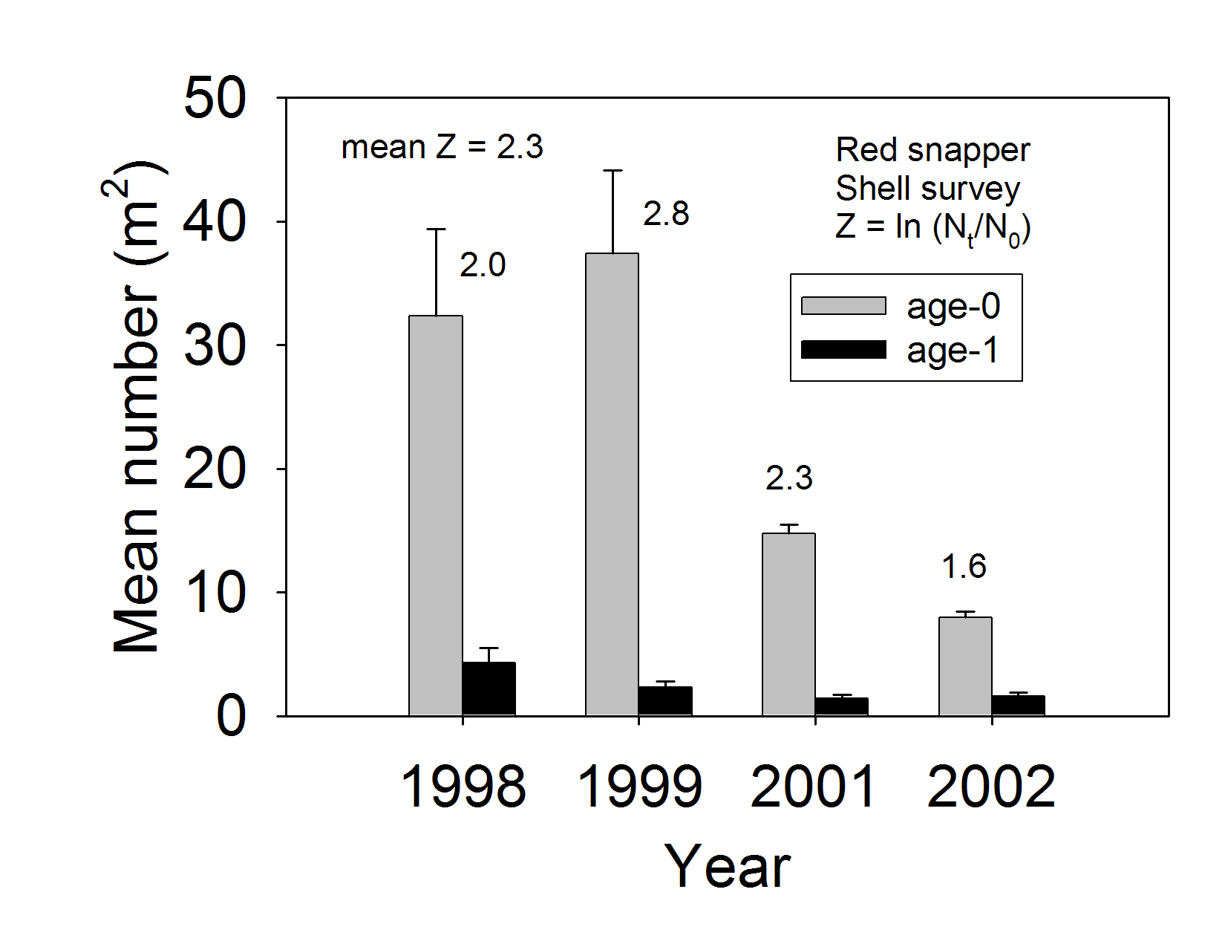

Figure 1.
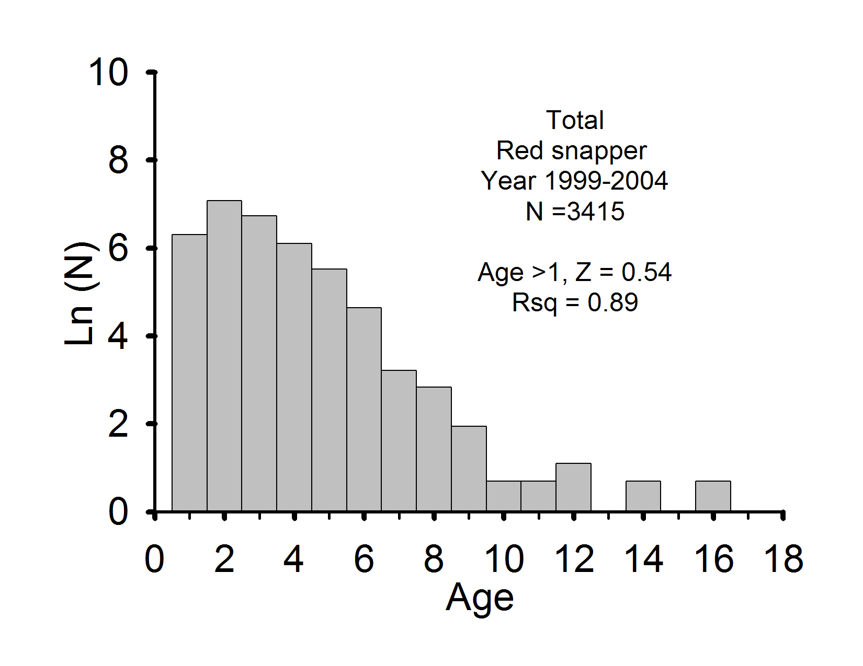

Figure 2.
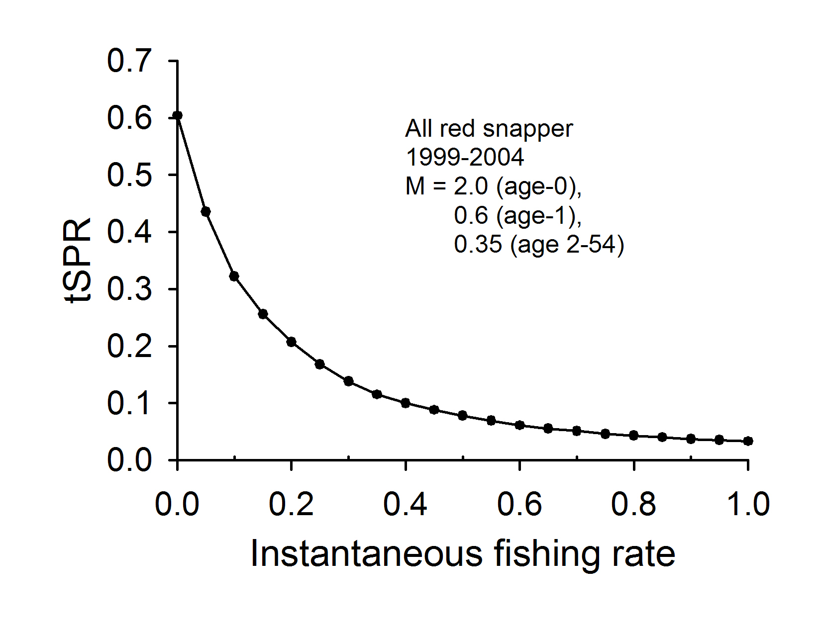

Figure 3.
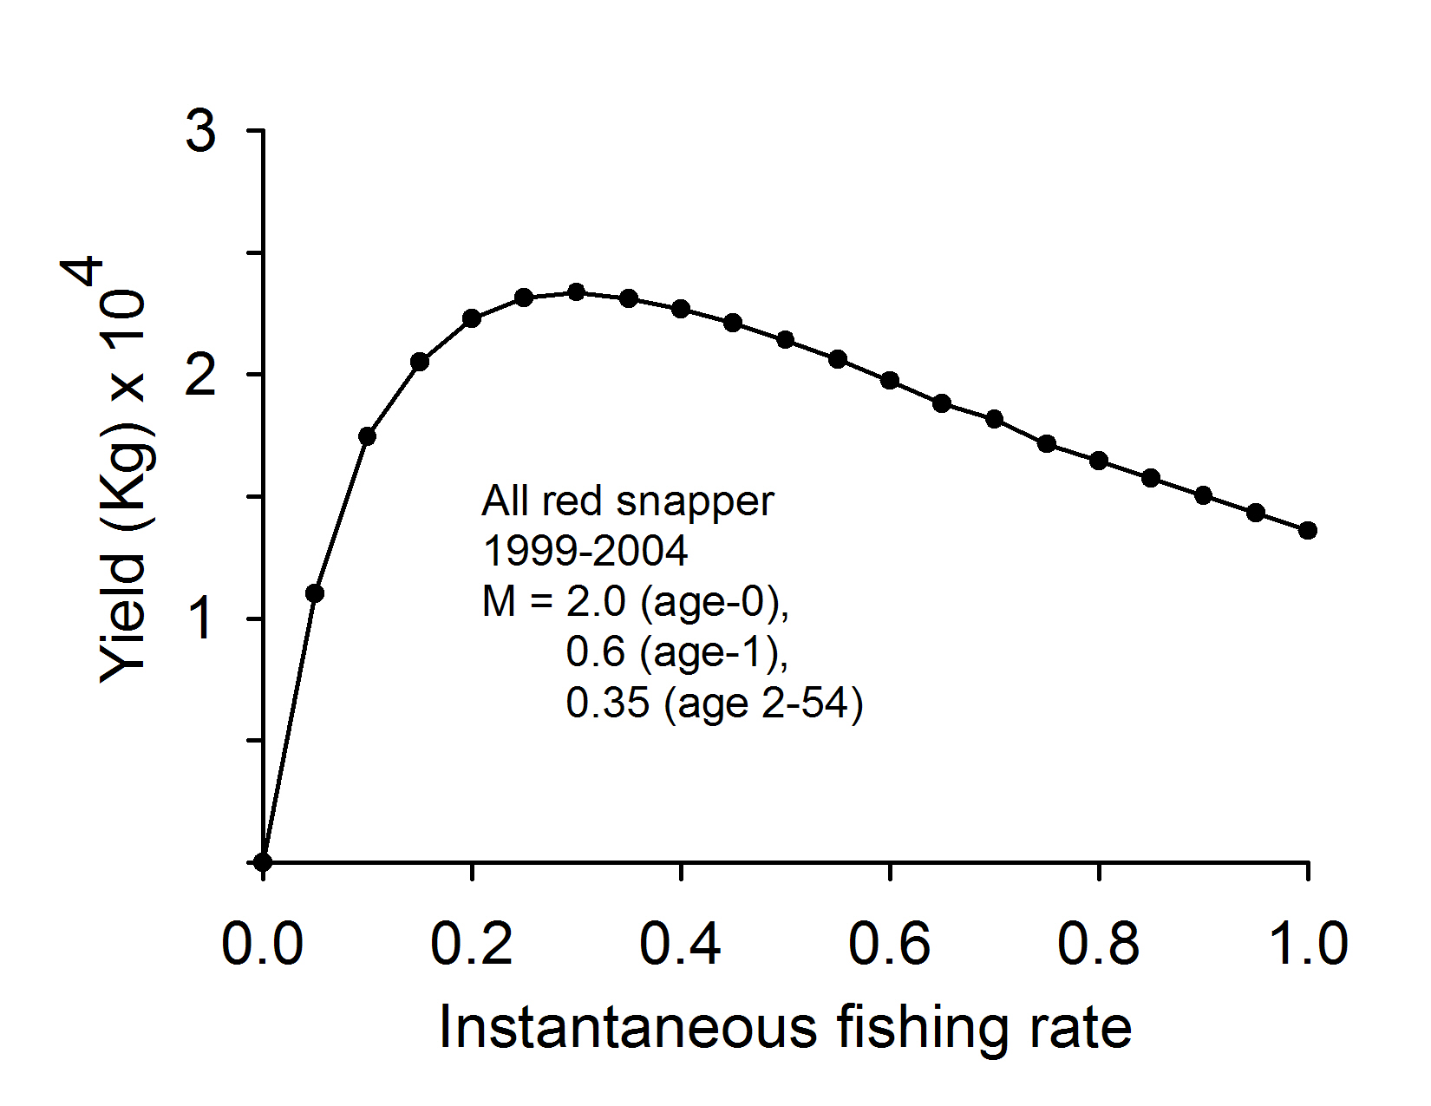

Figure 4.

